Title of the Paper

Authors
Affiliation
E-mail addresses

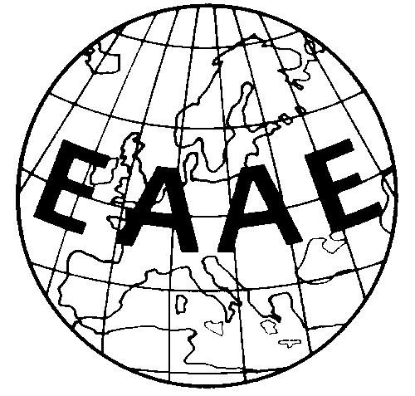

Paper prepared for presentation at the 173rd EAAE Seminar “Sustainable and resilient farming systems in the European Union”

September 26-27, 2019
Institute of Agricultural Economics, Romanian Academy
Bucharest, Romania

Copyright 2019 by [authors]. All rights reserved. Readers may make verbatim copies of this document for non-commercial purposes by any means, provided that this copyright notice appears on all such copies.

Title of the paper
Authors
Affiliation
E-mail addresses

Abstract
Max. 100 words, stating the objectives, methods, results, and main conclusions.

Keywords: up to five keywords
JEL Code:

Formatting full papers: 2.5 cm margins on all pages; justified text in Times New Roman 12 point font, single spacing; no underlining; all headings left justified; all headings in 12 point TNR; level one headings in bold, level two headings in bold, no level three headings; consecutive page numbers; all papers should use the template title page (see above); integrate figures and tables in the text.
Figure titles should be below the figure, left justified; table titles should be above the table. Please include sources. Use the equation editor for equations. Use double space between text and equations, and centre equations. Number equations consecutively.
References: Please refer to the style of the European Review of Agricultural Economics. References are cited in the text with name and year of publication. For direct quotes, please use page numbers (Swinnen, 1997: 12) or (Zeller et al., 1997). More information is available at: http://www.oxfordjournals.org/our_journals/erae/for_authors/index.html.
Please note that we will not edit papers. Authors take full responsibility for their own content.
Please use the seminar management system (conftool) to submit your contribution:
Submission for the 173. EAAE Seminar
When submitting the paper, please indicate in a separate email to the organizers whether or not you want your paper to be published on http://ageconsearch.umn.edu (AgEcon website).

